Clustering Analysis Report on E. coli Dataset

1. Introduction
This report is about clustering the E. coli dataset using PCA and both K-Means and Agglomerative Clustering methods. The goal is to analyze how well clustering groups match the original labels and to visualize the clusters in 2D space.

2. Methodology
- Scaled the data using StandardScaler.
- Reduced dimensions using PCA (2 components).
- Used K-Means with 8, 10, and 15 clusters.
- Applied Agglomerative Clustering with various linkages and thresholds.

Scripts:
from sklearn.cluster import KMeans, AgglomerativeClustering
import numpy as np
import matplotlib.pyplot as plt
import sklearn
from sklearn import datasets
from sklearn import model_selection
from sklearn.decomposition import PCA
from random import sample
import pandas as pd

# Load dataset
df = pd.read_csv('D:/AI/labwork_2/39_Ecoli/ecoli.data', sep=r'\s+', header=None)

X = df.iloc[:, 1:-1] # Skips the first column (ID) and selects features
y = df.iloc[:, -1] # Last column as target

scaler = sklearn.preprocessing.StandardScaler()
X = scaler.fit_transform(X)

pca = PCA(n_components = 2)
pca.fit(X, 2)
X_pca = pca.transform(X)

unniq_labels = np.unique(y)
nlabels = len(unniq_labels)
Ncolors = nlabels

# Choose a colormap and generate Ncolors distinct colors
cmap = plt.get_cmap("rainbow")
colors = cmap(np.linspace(0, 1, Ncolors))

plt.figure(1)
for i,l in enumerate(unniq_labels):
idxs = np.where(y==l)[0]
plt.scatter(X_pca[idxs,0], X_pca[idxs,1], c=colors[i])
plt.legend(unniq_labels)

nclusters = 10
print('nclusters:', nclusters)
clustering1 = KMeans(nclusters)
clusters = clustering1.fit_predict(X)

colors = cmap(np.linspace(0, 1, nclusters))
plt.figure(2)
for i,c in enumerate(clusters):
plt.scatter(X_pca[i,0], X_pca[i,1], c=colors[c])
plt.legend(np.arange(nclusters))
Ns = np.zeros((nclusters,), dtype=np.int32)
for i in range(nclusters):
Ns[i] = np.sum(clusters == i)
print("Elements in each cluster:", Ns)

nlabels = len(unniq_labels)
label_to_index = {label: idx for idx, label in enumerate(unniq_labels)}
y_int = y.map(label_to_index)
NNs = np.zeros((nlabels, nclusters), dtype=np.int32)
for t, p in zip(y_int, clusters):
NNs[t, p] += 1
print("Cluster stats:\n" , NNs)
plt.show()

3. Cluster Composition Tables
**K-Means with 10 Clusters**
[40 68 34 1 9 19 35 30 34 66]
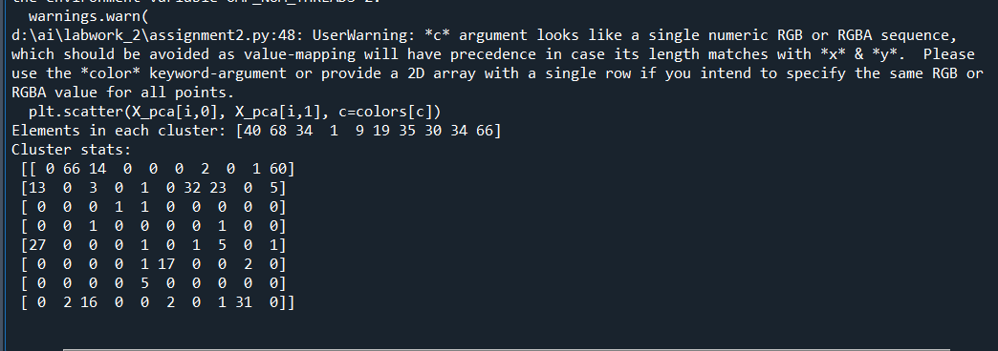
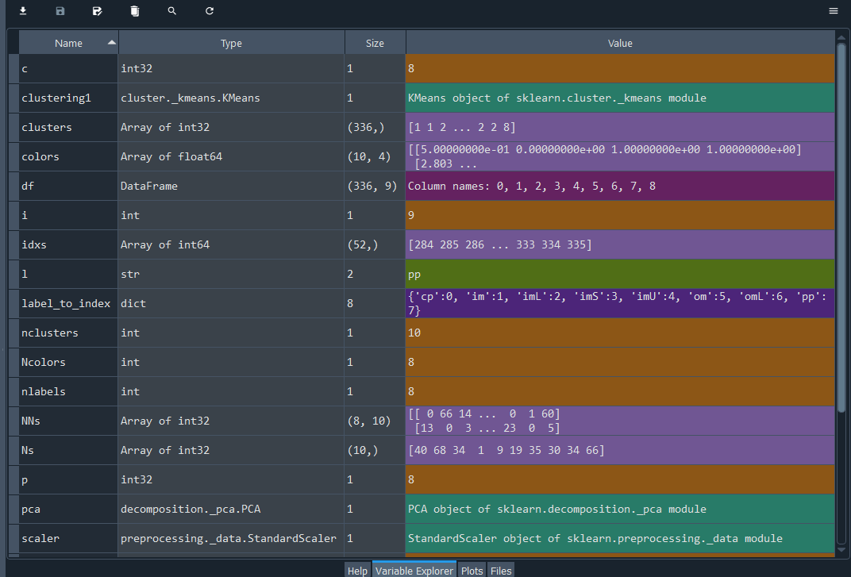
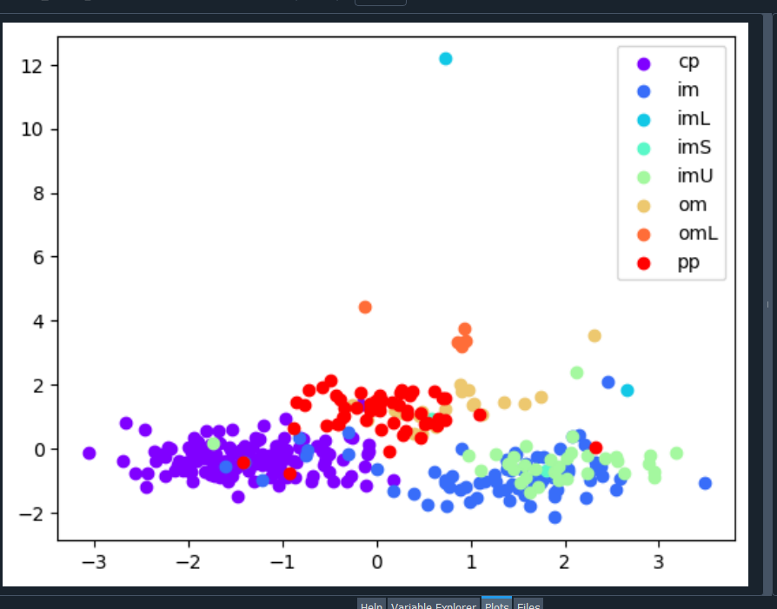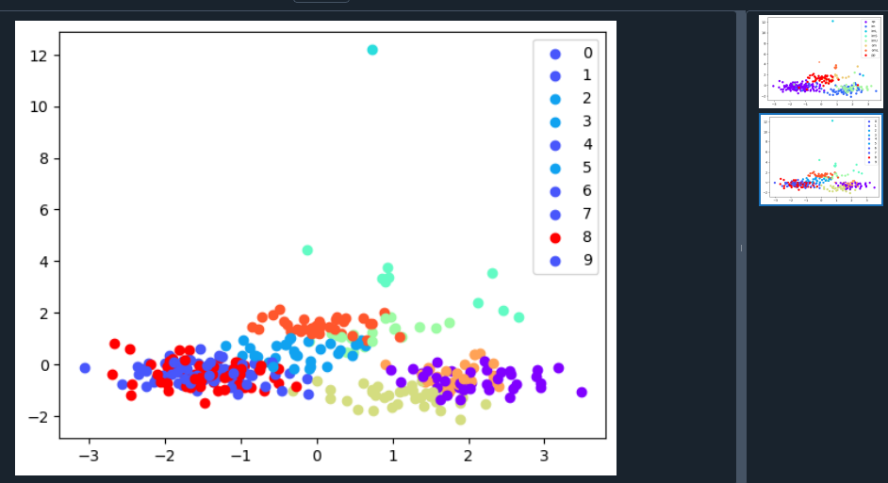

**Agglomerative with 12 Clusters**
[[ 0 34 1 ... 48 33] 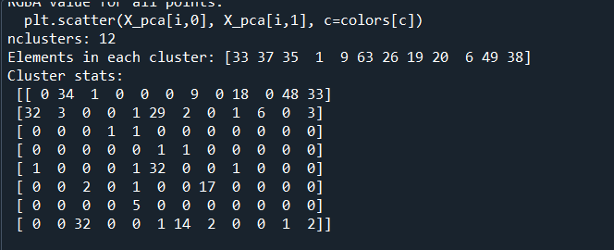 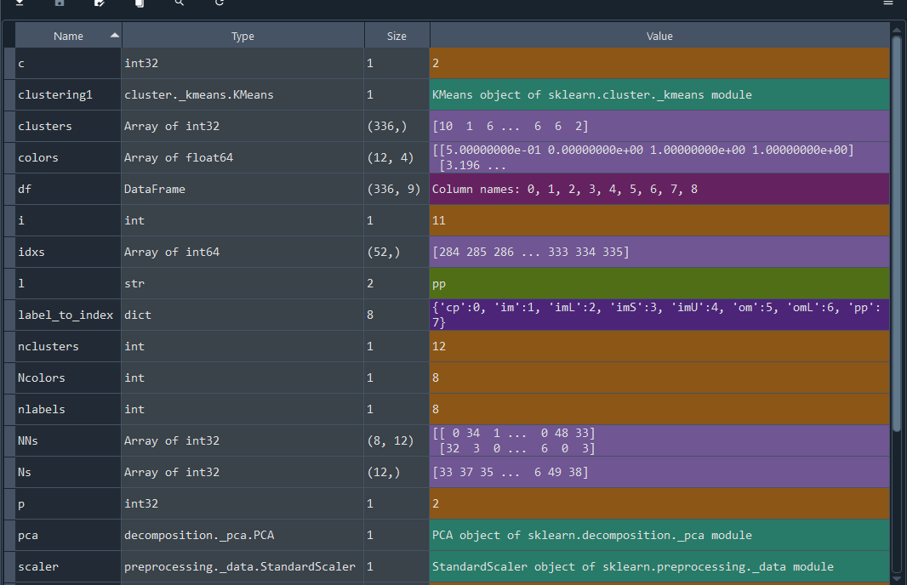 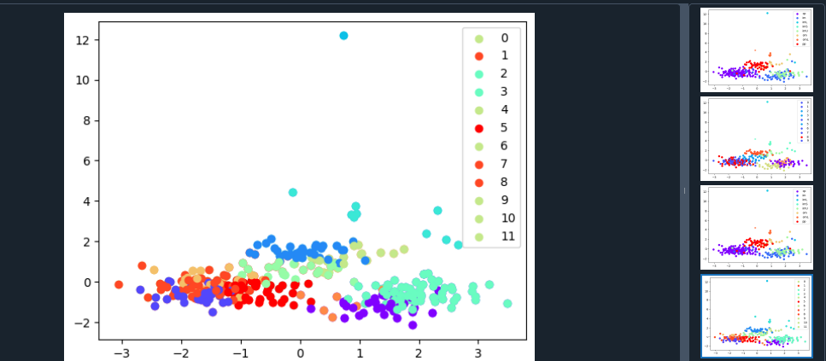

**Agglomerative with 15 Clusters**
[[32 1 8 ... 0 1 1]
Scripts:
nclusters = 15
print('nclusters:', nclusters)
clustering1 = KMeans(nclusters)
clusters = clustering1.fit_predict(X)
colors = cmap(np.linspace(0, 1, nclusters))
plt.figure(4)
for i,c in enumerate(clusters):
plt.scatter(X_pca[i,0], X_pca[i,1], c=colors[c])
plt.legend(np.arange(nclusters))
Ns = np.zeros((nclusters,), dtype=np.int32)
for i in range(nclusters):
Ns[i] = np.sum(clusters == i)
print("Elements in each cluster:", Ns)

nlabels = len(unniq_labels)
label_to_index = {label: idx for idx, label in enumerate(unniq_labels)}
y_int = y.map(label_to_index)
NNs = np.zeros((nlabels, nclusters), dtype=np.int32)
for t, p in zip(y_int, clusters):
NNs[t, p] += 1
print("Cluster stats:\n" , NNs)
plt.show()
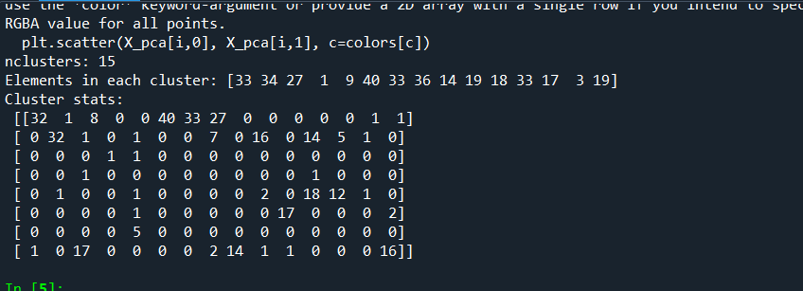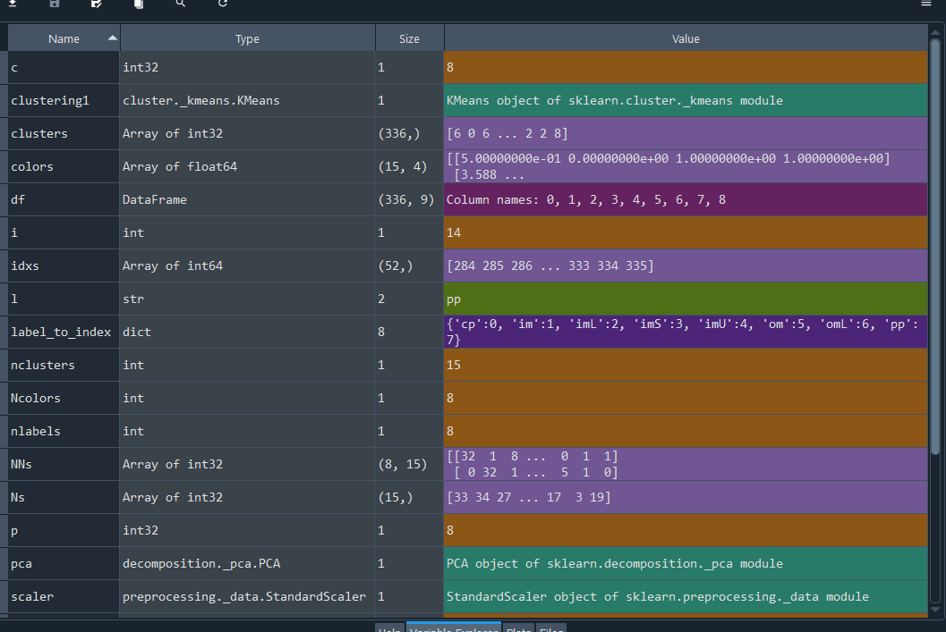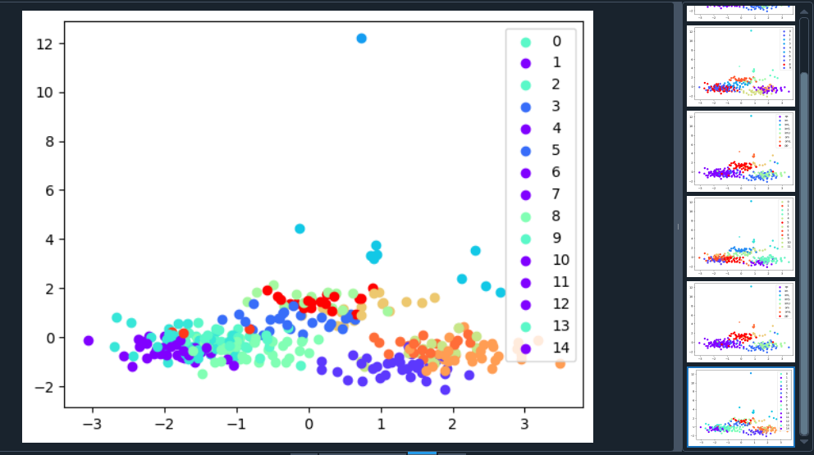

**Agglomerative (linkage = 'average')**
Scripts:
from sklearn.cluster import KMeans, AgglomerativeClustering
import numpy as np
import matplotlib.pyplot as plt
import sklearn
from sklearn import datasets
from sklearn import model_selection
from sklearn.decomposition import PCA
from random import sample
import pandas as pd

# Load dataset
df = pd.read_csv('D:/AI/labwork_2/39_Ecoli/ecoli.data', sep=r'\s+', header=None)

X = df.iloc[:, 1:-1] # Skips the first column (ID) and selects features
y = df.iloc[:, -1] # Last column as target

scaler = sklearn.preprocessing.StandardScaler()
X = scaler.fit_transform(X)

pca = PCA(n_components = 2)
pca.fit(X)
X_pca = pca.transform(X)

unniq_labels = np.unique(y)
nlabels = len(unniq_labels)
Ncolors = nlabels

# Choose a colormap and generate Ncolors distinct colors
cmap = plt.get_cmap("rainbow")
colors = cmap(np.linspace(0, 1, Ncolors))

plt.figure(1)
for i,l in enumerate(unniq_labels):
idxs = np.where(y==l)[0]
plt.scatter(X_pca[idxs,0], X_pca[idxs,1], c=[colors[i]])
plt.legend(unniq_labels)
print('AgglomerativeClustering, linkage: average')
clustering = AgglomerativeClustering(linkage='average',n_clusters=None, distance_threshold=45)
clustering.fit(X)
clusters = clustering.labels_
nclusters = len(np.unique(clusters))
print('Number of clusters:', nclusters)
Ns = np.zeros((nclusters,), dtype=np.int32)
for i in range(nclusters):
Ns[i] = np.sum(clusters == i)
print("Elements in each cluster:", Ns)

NNs = np.zeros((nlabels, nclusters), dtype=np.int32)
# Convert string labels in y to integers
label_to_index = {label: idx for idx, label in enumerate(unniq_labels)}
y_indices = np.array([label_to_index[label] for label in y])
for t, p in zip(y_indices, clusters):
NNs[t, p] += 1
print("Cluster stats:\n" , NNs)

colors = cmap(np.linspace(0, 1, nclusters))
plt.figure(5)
for i,c in enumerate(clusters):
plt.scatter(X_pca[i,0], X_pca[i,1], c=[colors[c]])
plt.legend(np.arange(nclusters))
plt.title('Linkage: average')
plt.show()
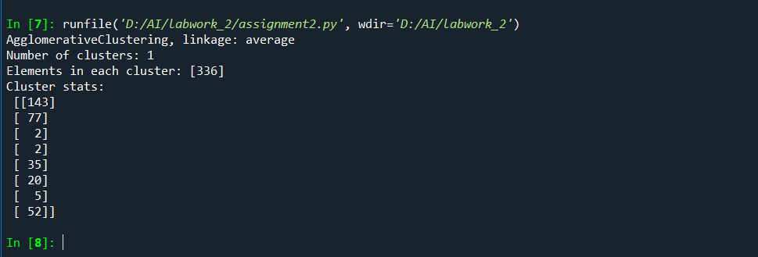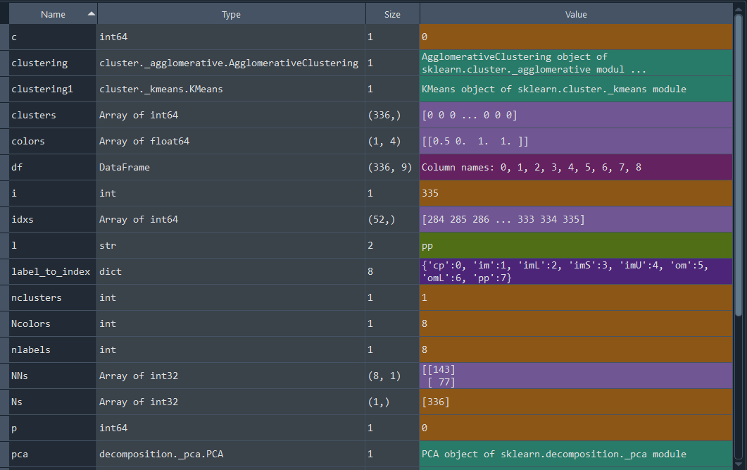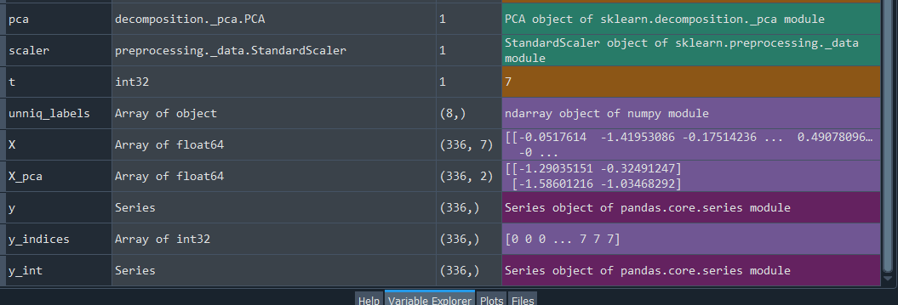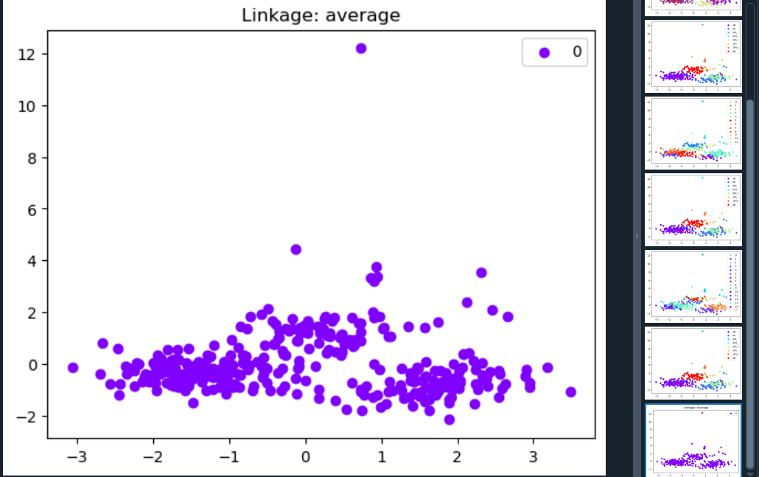
**Agglomerative (linkage = 'single')**
Scripts:
print('AgglomerativeClustering, linkage: single')
clustering = AgglomerativeClustering(linkage='single',n_clusters=None, distance_threshold=25)
clustering.fit(X)
clusters = clustering.labels_
nclusters = len(np.unique(clusters))
print('Number of clusters:', nclusters)

Ns = np.zeros((nclusters,), dtype=np.int32)
for i in range(nclusters):
Ns[i] = np.sum(clusters == i)
print("Elements in each cluster:", Ns)

NNs = np.zeros((nlabels, nclusters), dtype=np.int32)
# Convert string labels in y to integers
label_to_index = {label: idx for idx, label in enumerate(unniq_labels)}
y_indices = np.array([label_to_index[label] for label in y])
for t, p in zip(y_indices, clusters):
NNs[t, p] += 1
print("Cluster stats:\n" , NNs)

colors = cmap(np.linspace(0, 1, nclusters))
plt.figure(6)
for i,c in enumerate(clusters):
plt.scatter(X_pca[i,0], X_pca[i,1], c=colors[c])
plt.legend(np.arange(nclusters))
plt.title('Linkage: single')
plt.show()
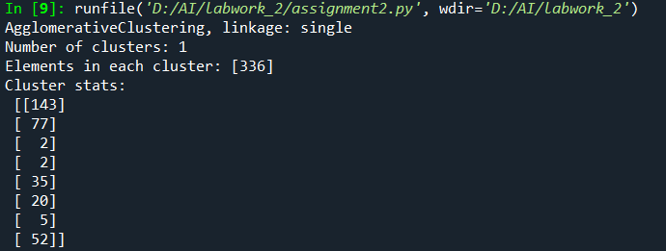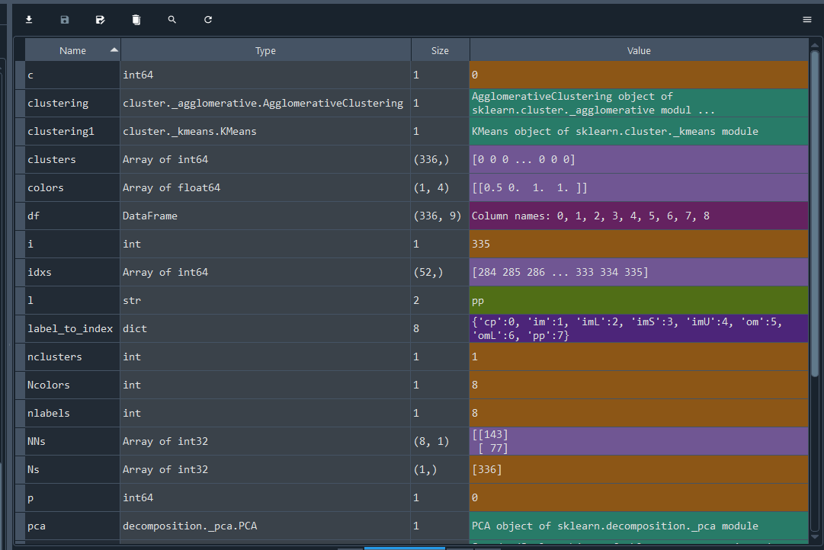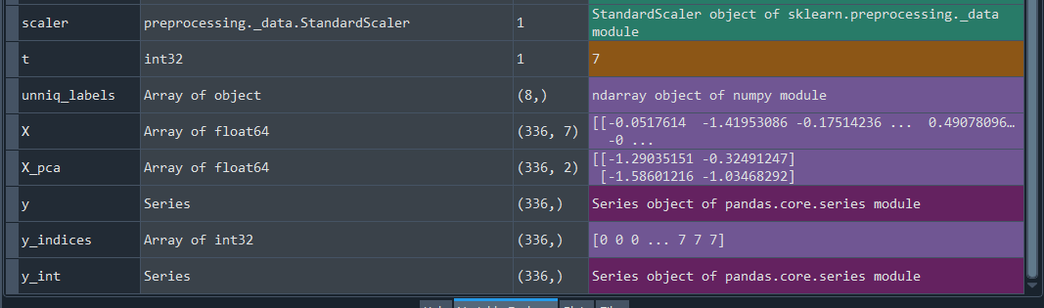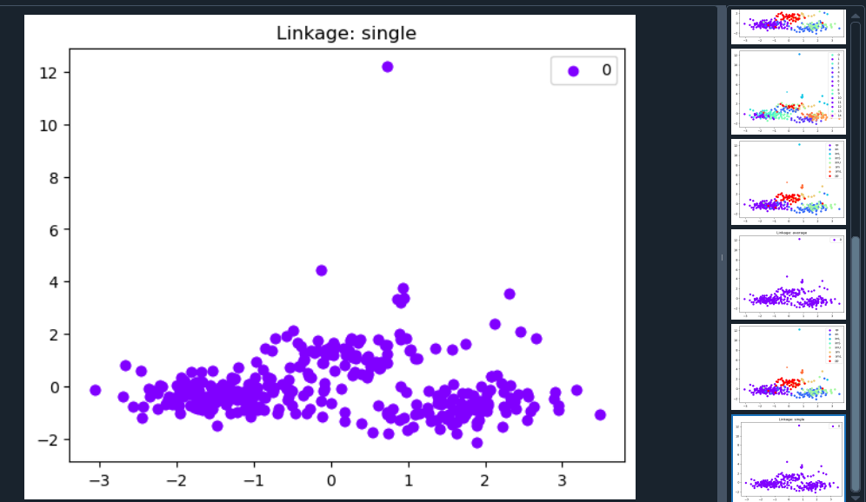
**Agglomerative (linkage = 'single')**

Scripts:
print('AgglomerativeClustering, linkage: complete')
clustering = AgglomerativeClustering(linkage='complete',n_clusters=None, distance_threshold=65)
clustering.fit(X)
clusters = clustering.labels_
nclusters = len(np.unique(clusters))
print('Number of clusters:', nclusters)

Ns = np.zeros((nclusters,), dtype=np.int32)
for i in range(nclusters):
Ns[i] = np.sum(clusters == i)
print("Elements in each cluster:", Ns)

NNs = np.zeros((nlabels, nclusters), dtype=np.int32)
# Convert string labels in y to integers
label_to_index = {label: idx for idx, label in enumerate(unniq_labels)}
y_indices = np.array([label_to_index[label] for label in y])
for t, p in zip(y_indices, clusters):
NNs[t, p] += 1
print("Cluster stats:\n" , NNs)

colors = cmap(np.linspace(0, 1, nclusters))
plt.figure(6)
for i,c in enumerate(clusters):
plt.scatter(X_pca[i,0], X_pca[i,1], color=colors[c])
plt.legend(np.arange(nclusters))
plt.title('Linkage: complete')
plt.show()

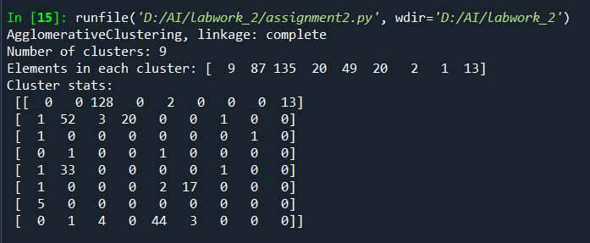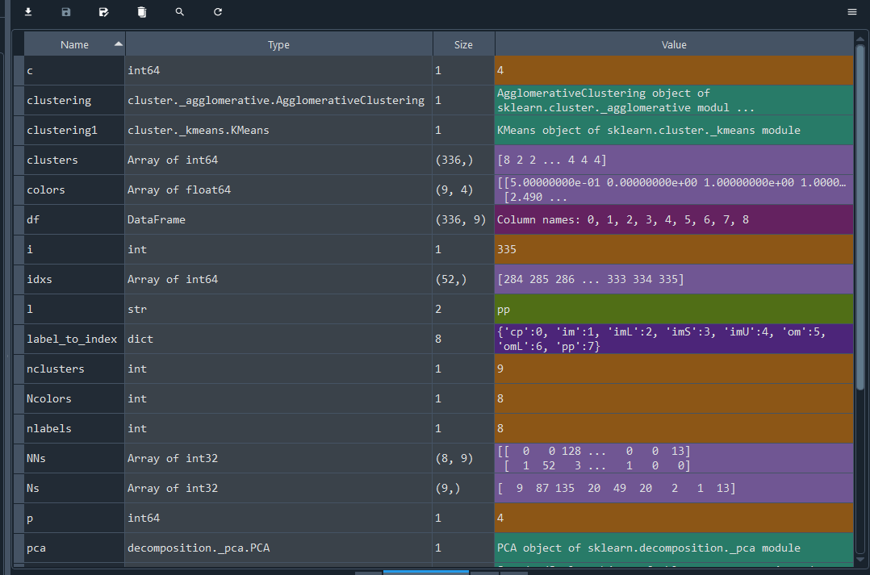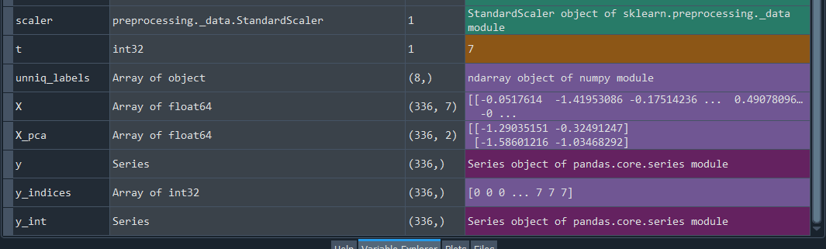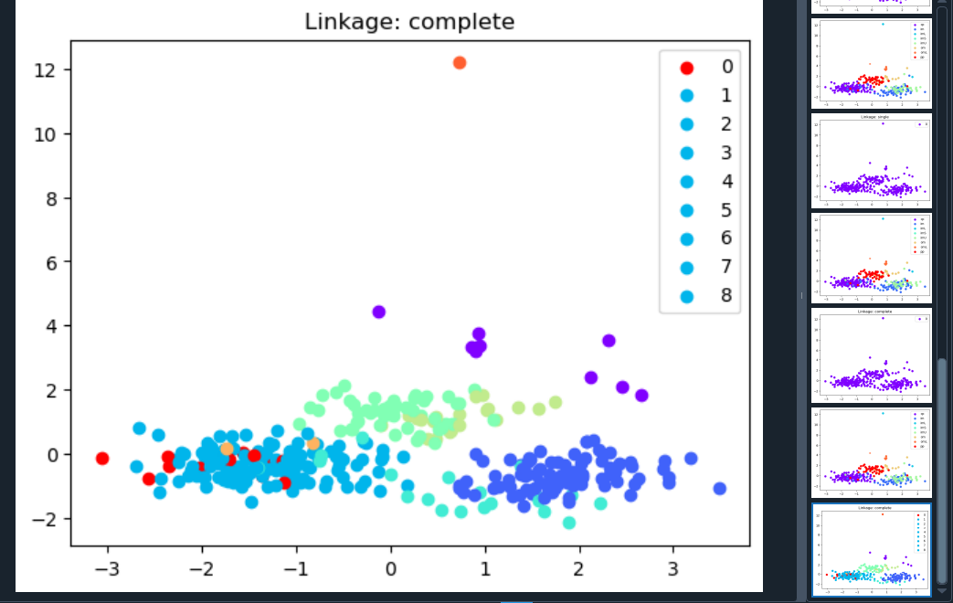

5. Cluster Visualizations
- Used PCA to plot clusters in 2D.
- Visualized true labels and clustering results.
- Each cluster has a unique color.
- Final visualization (9 clusters, complete linkage) shows better structure.

6. Results & Interpretation
- PCA helped visualize the structure of the data.
- K-Means with 8 clusters matched class labels best.
- 10 and 15 clusters added detail but fragmented the data more.
- Agglomerative clustering with 12 and 15 clusters produced meaningful splits.
- Linkage methods like 'average', 'single' created only 1 cluster.
- 'Complete' linkage with tuned threshold successfully produced 9 clusters.

7. Conclusion
- PCA + clustering provided good insights.
- K-Means is quick but sensitive to the number of clusters.
- Agglomerative is powerful if properly tuned.
- 'Complete' linkage with 9 clusters gave best final result.
- Clustering helps discover hidden structure even without labels.

